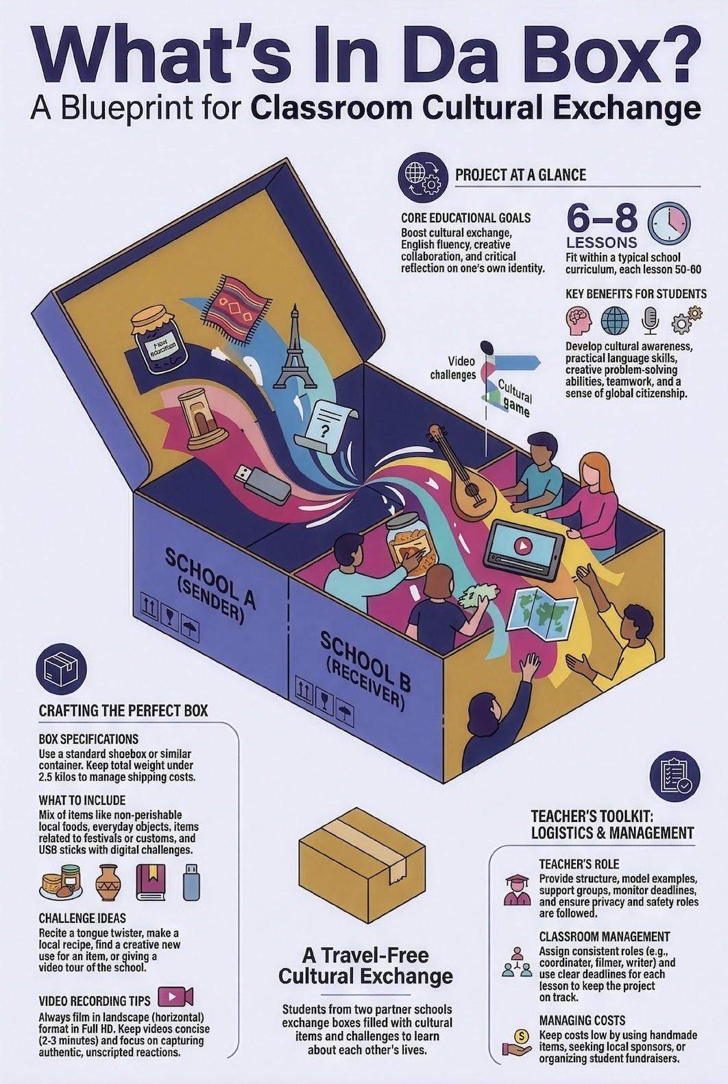
What’s In Da Box?
An international cultural exchange activity for students.

Introduction
This activity promotes cross-cultural understanding, teamwork, and creativity, all without requiring travel. Students from two partner schools exchange boxes filled with items representing their own cultures. Each box includes not only cultural artifacts but also challenges designed to encourage curiosity, language practice, and collaboration.
By participating in this activity, students reflect on their own cultural identity, gain insights into a different way of life, and build connections with their peers abroad.

Purpose
The main objectives of the activity are:
- Cultural Exchange: Help students appreciate cultural similarities and differences through hands-on experience.
- Language Fluency: Enhance English communication skills through challenges and interactions.
- Creative Collaboration: Encourage teamwork by creating and responding to challenges.
- Reflection and Learning: Encourage students to think critically about their own culture and traditions.

Time and Structure
Of course you are free to adapt this projects timing and structure to your own needs. Consider the following as a guide.
- 6–8 lessons (50–60 minutes each)
- Optional: extra lesson for vocational connection
- Combination of whole-class instruction, small-group work, and individual reflection

Classroom Management Tips
- Keep roles consistent to ensure accountability
- Use deadlines per lesson to avoid project overload
- Keep file sharing centralised (Teams, Google Drive, Trello, etc.)
- Address privacy rules early (no surnames or unintended people in the background)

Materials Needed
- Shoebox or similar container
- Simple props depending on chosen items
- Phones/tablets for filming, Basic editing tool (e.g., CapCut)
- Memory sticks with different challenges
- Rubrics / checklists (optional)

Teacher’s Role
- Provide structure and checkpoints
- Model short examples (labels, videos)
- Support groups with organisation
- Monitor deadlines, quality, and safety/privacy

Lesson Breakdown
Lesson 1 – Kick-off  - Explain project timeline & products  - Brainstorm cultural items (groups)  - Quick check to ensure understanding | Lesson 2 – Item Selection  - Groups propose items  - Class chooses final contents  - Assign roles: coordinator, writer, filmer, editor, reflector
Lesson 3 – Language Tasks  - Teacher models effective labels/questions  - Groups write English descriptions & challenges  - Peer feedback round | Lesson 4 – Pack & Plan  - Pack the box + take photos  - Create inventory list  - Set clear filming rules;  (horizontal, 2–3 min, no full names)

Shipping moment (outside lessons)
Lesson 5 – Unboxing  - Film spontaneous unboxing  - Students note observations & cultural comparisons  - Class discussion | Lesson 6 – Challenges  - Groups complete 1–2 challenges  - Produce short challenge videos  - Mid-lesson check on quality & clarity
Lesson 7 – Reflection  - Group presentations: what did we learn?  - Individual reflection (text or 1-minute video)  - Create thank-you message/video | Lesson 8 (optional) – Vocational Link  - Students relate cultural insights to their profession

Instructions for the Box Exchange

1. Preparing the Box
Students will decide on the content of the box, focusing on items that represent their culture and are likely to interest people from another country. Teachers will assist by providing suggestions, ensuring variety, and avoiding duplicates.
Suggested Box Guidelines:
- Use a typical shoebox or a similarly sized container.
- Keep the weight under 2.5 kilos to ensure manageable shipping costs.
- Include a mix of items such as:
  - small food items (non-perishable and culturally significant).
  - traditional or everyday objects.
  - items related to a local custom, festival, or tradition.
  - USB memory sticks with different challenges

2. Adding Questions and Challenges
Each item in the box should include a label with a question or a challenge that encourages curiosity and interaction.
Examples of Questions:
- “What do you think this item is used for?”
- “In our country, this is used during [name of celebration]. How would you use it in your culture?”
Examples of Challenges:
- Tongue Twisters; try to speak out loud the tongue twister in the original language,
- Make this typical recipe and taste it with your classmates,
- Find a creative use for this item in your daily life and share it in a short video,
- Show me your school in a 2 minute short video.
- Introduce yourself/your class creatively. For example: use a curtain that opens and closes after each introduction (original idea from a Dutch tv program: “Achterwerk in de kast”).
Challenges should align with the activity’s goals of cultural exchange, language practice, and creative problem-solving.

3. Shipping the Box
Before shipping, ensure the box is properly packed to avoid damage. Confirm the postal service's size and weight limits for international shipping in your country. Partner schools should discuss and agree on:
- Expected delivery timelines.
- The type of items allowed (e.g., some countries restrict food or plants).
- Shared costs, if necessary.

Unboxing and Reflection

1. Unboxing the Box
The unboxing should be a fun and spontaneous experience. Students should focus on expressing their genuine reactions to the items and challenges.
Tips for Recording the Unboxing:
- Film in landscape format to ensure the video is suitable for sharing across different platforms.
- Use one or more cameras or phones capable of recording in Full HD (1920x1080p) for clear and professional-looking footage. Edit the unboxing together in free software like CapCut. (Or ask mediadesign students to assist in shooting and editing).
- Keep the atmosphere informal and relaxed. There’s no need for a script—encourage students to simply enjoy the moment.

2. Reflecting on the Experience
After the unboxing, students will engage in reflection activities to deepen their understanding of the other culture.

Suggested Reflection Activities:
- Group Discussion: What surprised you about the items? How are they similar to or different from items in your own culture?
- Creative Outputs: Create a poster, blog post, or short video summarizing what you’ve learned.
- Response Letters or Videos: Write a thank-you note or create a short video to share your thoughts on the experience with the sending school.

Creating and Responding to Challenges

1. Designing Challenges
Challenges should be designed to engage the receiving students in exploring and interacting with your culture. They can be creative, fun, and thought-provoking.
Examples:
- Cook a traditional dish from our country using this recipe.
- Perform a cultural dance with your classmates and film it.
- Use this item in an unexpected way and share your creative solution.

2. Completing Challenges
The receiving class will complete the challenges and record their efforts. Encourage them to be creative and authentic while filming.
Tips for Challenge Videos:
- Follow the same video guidelines as for the unboxing (landscape format, Full HD).
- Include all participants where possible, showcasing teamwork.
- Keep videos concise, aiming for 2–3 minutes per challenge.

3. Sharing Challenge Results
The completed challenge videos should be sent back to the sending school within an agreed time frame (e.g., one month). This allows the sending students to see how their ideas were interpreted and executed, closing the loop of the exchange.

Costs and Logistics

1. General Cost Considerations
The costs of this activity will largely depend on the items chosen and the weight of the box. Both schools should discuss and agree on a general budget to ensure fairness and feasibility.
Key Cost Factors:
- Items in the Box: Non-perishable, lightweight items are ideal to minimize costs.
- Shipping Costs: Using a standard shoebox size (or similar) and keeping the weight under 2.5 kilos can help manage expenses.
- Packaging Materials: Ensure items are packed securely to avoid damage during transit.
Practical Tips:
- Confirm postal rates and size/weight restrictions with your local service before finalizing the box.
- Opt for economic shipping options where possible, as delivery time is often flexible.
- Share tracking information with the partner school to monitor the shipment's progress.

2. Suggestions for Managing Costs
- Collaborate with local sponsors: Start within your own school, local businesses, cultural organizations, or community groups may be interested in supporting an international exchange. They could donate items or help with shipping costs.
- Engage students in fundraising: Organize bake sales, raffles, or other fundraising activities to involve students and lower the cost burden.
- Leverage school resources: Schools with carpentry or art departments could even create custom boxes, reducing costs and adding a personal touch and branding.
- Focus on creativity: Encourage students to include handmade or low-cost items that are meaningful rather than expensive.

Summary and Benefits
What’s In Da Box? is a creative and accessible way to foster cultural exchange and collaboration between students from different countries, all without the need for travel. By preparing and exchanging boxes filled with cultural items and challenges, students gain a unique opportunity to explore and share their traditions, develop language skills, and build global connections.

Key Benefits
- Cultural Awareness
Students learn to appreciate cultural differences and discover unique aspects of another country’s traditions, habits, and way of life.
- Language Development
The activity encourages students to use English in practical, real-world contexts, improving both their fluency and confidence.
- Creative Problem-Solving
Designing and completing challenges pushes students to think outside the box and use their creativity.
- Teamwork and Collaboration
Working together to prepare the box and complete challenges strengthens students’ ability to collaborate effectively.
- Personal Growth
Reflecting on their own culture and engaging with others helps students develop a broader perspective and a sense of global citizenship.

Next Steps
- Identify a partner school and agree on timelines, box guidelines, and communication methods.
- Begin brainstorming and preparing items for the box with your students.
- Coordinate shipping details and ensure the box is packed securely.
- Plan an informal, fun unboxing event and share videos with your partner school.
- Complete and return challenge videos, reflecting on the experience as a class.

This activity offers a fun and enriching way to bring the world into the classroom while equipping students with essential skills for the future.
